READ THE FOLLOWING TRANSCRIPT OF A BBC RADIO BROADCAST IN GREAT BRITAIN and the summary that follows in the shaded box

1942: Rommel goes on the run at El Alamein

The German army in North Africa is in full retreat, after suffering a comprehensive defeat in Egypt at the hands of the 8th Army under General Bernard Montgomery.
News of the victory came in a special joint war report from British Headquarters in Cairo this evening.
It described the retreating columns of German soldiers as "disordered" and said they were being "relentlessly attacked by our land forces, and by the Allied air force, by day and night."
It went on to say that Allied troops have captured more than 9,000 prisoners of war, including the commander of Germany's Afrika Korps, General Ritter von Thoma.

“We passed through safely, but many didn't: a number of heaps of blackened metal - some still burning - lay on either side of the track.”

Casualties among the German troops are known to have been high.
The King sent a message of congratulations to the Allied Commander in Egypt, General Harold Alexander, saying "The 8th Army... has dealt the Axis a blow of which the importance cannot be exaggerated."
It has taken 12 days and nights of fierce fighting around the desert village of El Alamein to drive back the massed forces of the German commander, Field Marshal Erwin Rommel.
The village is at a bottleneck in the corridor formed by the Mediterranean coast on one side, and the impassable salt marshes of the Qattara Depression to the south.
The 8th Army has been dug in there, holding back Rommel's advance towards Cairo, ever since the first Battle of El Alamein in July.
The second Battle of El Alamein began on 23 October with a heavy bombardment of the Germans' five-mile-deep minefields to drive a way through for Allied troops.
Since then progress has been grindingly slow as the German army put up a hard-fought defense. But inch by inch, the Allied soldiers made their way forward.
The first indications that victory was imminent came yesterday, when the Germans abandoned a whole series of important positions without a shot being fired.
Then long columns of enemy transports began to build up along the coast road as the retreat began.
The triumph is already being described as the beginning of the end for Adolf Hitler in North Africa.
After months of defeat, retreat and stalemate, it is exactly the change in fortunes the Allies need to drive him out of Africa altogether.

The Allied victory in the Second Battle of El Alamein was a huge morale boost after a long period of attrition in North Africa. It made a national hero out of General Montgomery, whose “Desert Rats” finally emerged victorious over the “Desert Fox,” German General Erwin Rommel, who commanded the Afrika Corps, comprised mostly of Italian troops. The Afrika Corps threatened Allied access to Middle Eastern oil supplies.
It was greatly helped by a string of setbacks suffered by the Germans.
Rommel was ill when the battle started, and his deputy then died of a heart attack, leaving a third general in temporary command until Rommel's return.
The Germans were also badly weakened by chronic shortages of fuel and equipment due to their long supply lines.
One of the trump cards contributing to the Allied victory was the hammering they gave the German Panzer tank divisions.
Rommel started with 500 tanks: by the end of the first phase, he was down to just 100 and after a massive tank battle on the last day he was left with just 30 serviceable tanks. General Montgomery had delayed pursuing Rommel while he waited for the arrival of 300 Sherman tanks from United States. The Sherman’s were armed with a 75mm gun that shot a 6 lb. shell that could penetrate the German Panzer at 2,000 meters (but most of Rommel’s tanks were not Panzers, they were inferior Italian tanks).
The Second Battle of El Alamein was not quite the end for Hitler in North Africa, but it did turn the tide decisively against him.
Four days later, on 8 November, American and British forces invaded French North Africa in Operation Torch, the first major joint Allied offensive of World War II.
They overwhelmed the Vichy French resistance, and the remnants of the Axis forces in North Africa finally surrendered on 13 May 1943.

Station: Battle of the Bulge (Hitler’s last attempt)
Summary: The Battle of the Bulge was Germany's last offensive on the Western Front. It was a very ambitious plan and while initially successful, the surprise German counteroffensive stalled by the end of December 1944. The objective was to gain crossings over the Meuse River and then advance and capture the port of Antwerp. Initially the counter-offensive caught the American and British forces by surprise and created wide confusion among the largely inexperienced troops stationed in the Ardennes Forest. Some German forces managed to advance deep into the Allied lines; however they had failed to capture the strategic town of Bastogne. Combined with winter weather, fierce fighting, rough terrain, and superior Allied air power, the offensive was eventually contained around December 25th and the Germans were forced to retreat over the Rhine and into Germany itself.
Outcome: The Battle of the Bulge is remembered, even today, as the bloodiest battle for the United States military, and one of the biggest in all of WWII. Though it lasted just more than a month, from December 16, 1944 to January 25, 1945, more than 80,000 American soldiers were killed, injured, or captured by German forces.
Excerpt from speech given by Gerd von Rundstedt, Commander in the German army:
Soldiers of the Western Front! Your great hour has arrived. Large attacking armies have started against the Anglo-Americans. I do not have to tell you more than that. You feel it yourself. WE GAMBLE EVERYTHING! You carry . . . the holy obligation to give everything to achieve things beyond human possibilities for our Fatherland and our Fuhrer!
Excerpt from speech given by Hitler right before the Battle of the Bulge:
“This battle is to decide whether we shall live or die. I want all my soldiers to fight hard and without pity. The battle must be fought with brutality and all resistance must be broken in a wave of terror. . .”
Task: Imagine you are a German solider, and are preparing to go to the Battle of the Bulge. You just heard Gerd von Rundstedt and Adolf Hitler speak about why and how you need to fight for Germany. Answer the following questions in a letter home to you parents on your feelings toward the upcoming battle. (If you do not adequately answer these questions in your letter, you will not receive credit.)
- Based on the excerpts you’ve read, why do you feel you need to fight this battle?
- Do you think you Germany is going to win the battle?
  - What are some factors against you?
  - What are some factors for you?
- Based on the speeches, do you think you will survive the battle?

Station: Battle of Stalingrad
Watch the video: http://www.history.com/topics/world-war-ii/world-war-ii-history/videos/world-war-ii-battle-of-stalingrad
Task: Create a timeline of the events of the Battle of Stalingrad based on the information and photo captions below.
Summary: The Battle of Stalingrad began on August 23, 1942. The Luftwaffe went on nightly bombing raids that set much of the city ablaze and reduced the rest to rubble. The situation looked desperate. Nonetheless, Stalin had already told his commanders to defend the city named after him to the death. In September Soviet High Command (Stavka) appoints Vassily Chuikov to lead the defense of the city.

By early November 1942, Germans controlled 90 percent of the ruined city. Then another Russian winter set in. On November 19, Soviet troops outside the city launched a counterattack (Operation Uranus). Closing in around Stalingrad, they trapped the Germans inside and cut off their supplies. General Paulus begged Hitler to order a retreat. But Hitler refused, saying the city was “to be held at all costs.”

On February 2, 1943, some 90,000 frostbitten, half-starved German troops surrendered to the Soviets. These pitiful survivors were all that remained of an army of 330,000. Stalingrad’s defense had cost the Soviets over one million soldiers. The city was 99 percent destroyed. However, the Germans were now on the defensive, with the Soviets pushing them steadily westward.

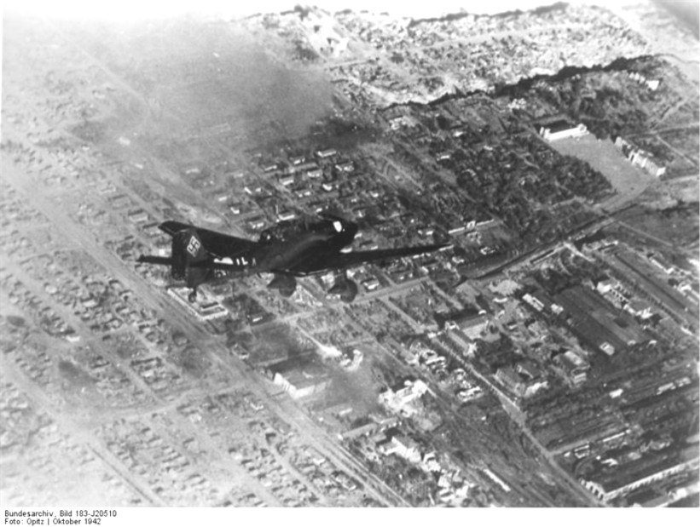
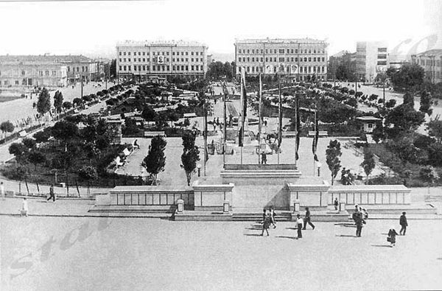
Stalingrad 1942 before the German attack August 23, 1942 Battle of Stalingrad
begins as the Luftwaffe begins to bomb
the city itself as well as Soviet shipping
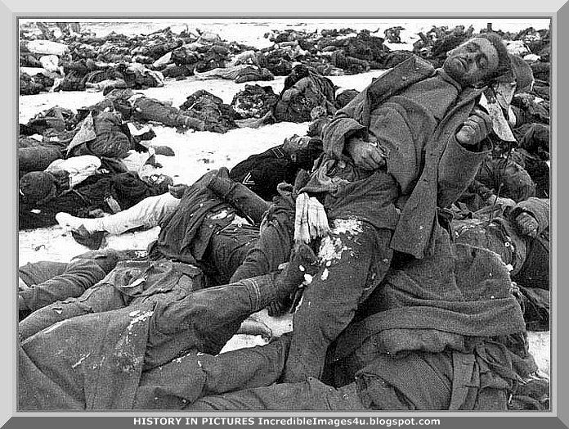
on the Volga River
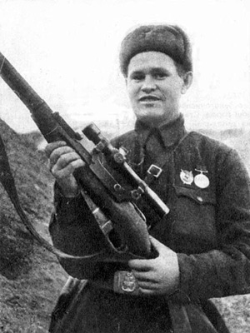
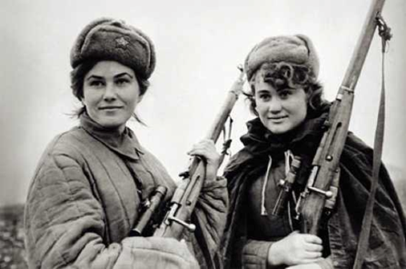

Women Snipers
September 13, 1942 - German ground
offensive starts in the city Vassily Chuikov

