The Cold War in the 1960s, 1970s and 1980s

I. THE COLD WAR WHEN STALIN WAS DICTATOR
A. _____________ ______________led the Soviet Union from 1927 to 1953
1. When the Cold War began, Stalin spread communism into the _________________ _____________in Eastern Europe
2. Stalin escalated the Cold War by ____________________West Berlin in 1948
3. Under Stalin, the USSR tested the ___________ __________in 1949 and _______________ ___________in 1953
4. Stalin signed a “__________ ______ _____________” with Chinese leader Mao Zedong after the Chinese Revolution
5. Stalin sent weapons to the communists in __________ ____________during the Korean War
B. Joseph Stalin’s __________in 1953 ____________the Soviet Union and how it approached the Cold War against the US

II. THE COLD WAR FROM 1953 TO 1980
A. Nikita Khrushchev and De-Stalinization
1. New USSR leader Nikita Khrushchev began a series of _____________known as “_____________________________”, which included releasing political prisoners and relaxing censorship
2. Khrushchev seemed willing to __________ ________the USA to ease Cold War tensions… However, _____________ between the USA and USSR would escalate throughout the 1950s and 1960s
a. Under Khrushchev, the Soviet Union launched Sputnik and the ____________ __________began
b. The creation of ICBMs led to the stockpiling of nuclear weapons during the __________ __________
B. In 1961, John F. Kennedy became U.S. President; Kennedy and Khrushchev faced two important crises that heightened Cold War tensions: building of the __________ ___________and the ____________ ____________ ____________
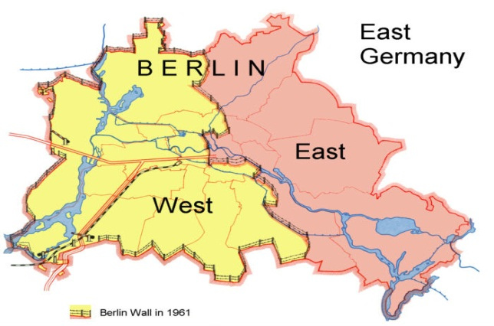
1. BERLIN WALL, 1961
a. Khrushchev was upset with the increasing number of communist East Germans who moved to ________________ ______ __________
b. In 1961, Khrushchev threatened to _______ ______ ___________ to West Berlin (like Stalin’s blockade in 1948). President Kennedy promised to ______________West Berlin
c. Rather than use the Soviet military to blockade the city, Communist leaders built the Berlin Wall to ___________ ________ ___________ out of West Berlin
d. The Berlin Wall became the ___________ ____________and the ___________ _____________of the Cold War
2. CUBAN MISSILE CRISIS, 1962
a. When _______ _________seized power in Cuba in 1959, the US feared the spread of communism close to America
b. After a failed attempt by the US to overthrow Castro, Khrushchev secretly sent __________ ____________to Cuba
c. The U.S. successfully ____________________Cuba; Khrushchev removed the ICBMs from Cuba in exchange for the removal of American ICBMs in Europe
d. The ____________ ____________ ______________was the closest the USA and USSR came to nuclear war

C. VIETNAM WAR, 1965-1973
1. From 1965 to 1973, the USA became involved in the _________________ _________, which was at first a fight between France and Vietnam
a. France made Vietnam a colony for many years, ______________________the people and resources; the Vietnamese fought to be _____________of France
b. When communist leader Ho Chi Minh gained independence for Vietnam, the USA feared _____________________ ______________in Southeast Asia
c. Vietnam had become _________________: North Vietnam was communist, while South Vietnam was democratic
d. In South Vietnam, communists known as the _________________worked to unify North and South Vietnam; to ___________ ______________, the United States sent troops to Vietnam to support the South, starting in 1965
i. The American military used bombing raids, herbicides, and search-and-destroy missions to fight the Vietcong; Herbicides were used by the U.S. to kill off the ____________ ___________, so the V-C could not hide there; the chemicals would have ____________ _______ __________on the soldiers’ health as well as Vietnamese civilians
ii. Despite these efforts, the U.S. was _________________to defeat the communist enemy
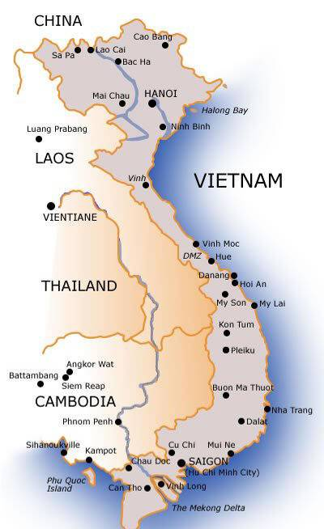
e. The Vietcong were ____________ _____________and did not play by the rules of war; hit-and-run guerilla fighting, deadly ________________, and __________________made the Vietcong extremely difficult to fight against
f. Another factor that made it difficult for the U.S. troops was that the North Vietnamese (the enemy) ____________ _____ _________as the South Vietnamese
g. The stress of not knowing who the enemy truly was, the _________ __________ of the V-C, and the unpleasant jungle terrain led to __________ _______________ and serious drug abuse among the young U.S. troops (average age was 19); Breakdowns led to murders and war crimes by American troops, such as the ______ _____ _______________, where U.S. soldiers _____________________an entire village of women, children, and the elderly
h. Pictures showing things like Vietnamese children screaming as American-delivered _____________________burns their skin, caused _________________ and disgust among the American public
i. The Vietnam War was _____________________, hurt the American economy, and became __________________with anti-war protestors in the United States
j. In 1973, the USA ____________________from Vietnam; two years later the Northern communists ____________ _______________ the South and unified Vietnam

D. DÉTENTE IN THE 1970s
1. America’s __________________in Vietnam led to a change in Cold War policies; the USA abandoned its containment policy and began looking for ways to ______________ ____________with Cold War enemies
2. In the 1970s, President Nixon’s policy of __________________ (easing Cold War tensions) replaced brinkmanship
a. Recognition of China
i. In 1972, Nixon became the ____________U.S. president to visit China and to ______________ _______________ as the legitimate government of China
ii. Nixon’s visit to China put pressure on the Soviet Union to _____________________with the USA
b. Détente with the Soviet Union
i. In 1972, Nixon met with Soviet leader Leonid Brezhnev to discuss nuclear arms ____________________
ii. The USA and USSR signed the Strategic Arms Limitation Talks (________) which __________________the number of ICBMs each nation could have
iii. By the 1970s, the USA and USSR seemed willing to __________________ _________________

E. SOVIET INVASION OF AFGHANISTAN, 1979-1989
1. But, ___________ ____________in 1979 when the USSR invaded Afghanistan to put down an anti-communist uprising
a. The U.S. viewed the __________________as an attempt to spread communism into South Asia and the Middle East
b. The United States cut off all _________with the USSR and sent military and economic aid to ________ __________
2. The USSR fought in Afghanistan from 1979 to 1989, but was ____________ _____ ___________ the Afghan resistance
a. The war exhausted the Soviet economy and proved as ___________________as Vietnam was for the United States
b. The war ______________ ________________between the USA and USSR

