Unit 3: Study Guide- The Middle Ages in Europe
Directions: To be best prepared for your test review your notes, handouts, and goal sheet from the unit. Answer the questions below using your work and the textbook chapters from this unit.

- Who was Charlemagne? Why is he significant to Western Europe after the fall of Rome?
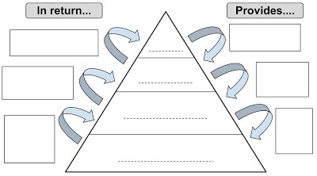
- How was Western Europe different after the fall of Rome?
- Who were the Vikings? Where did they come from? What did they do?
- Define feudalism and the feudal contract.
  - Why did this system develop in Western Europe?
- Describe the social order in Europe during this period using the image to the right.
- What was the role of a knights in the Middle Ages?
- What was the Code of Chivalry? Was it followed all the time?
- Be able to describe the changes happening Europe in the areas of
  - Agriculture
  - Trade
  - Growth in cities
- Describe the Manorial System.
- What are guilds? What did they do?
- Who was William of Normandy?
- What happened at the Battle of Hastings?
- How did development during this time especially in England and France represent steps towards ordinary people gaining rights and weakening the power of the monarc?
  - Magna Carta
  - Edward I
  - Louis IX
  - Philip IV
- What was the Reconquista? .

